- Create a simple blog homepage (HTML only) with at least 3 article links. Make sure each article link uses descriptive anchor text instead of 'click here' or 'read more'.

<!DOCTYPE html>
<html lang="en">
<head>
<meta charset="UTF-8">
<meta name="viewport" content="width=device-width, initial-scale=1.0">
<title>My Blog</title>
</head>

<body>

<header>
<h1>My Blog</h1>
<p>Insights, ideas, and helpful guides for everyday life.</p>

<nav>
<a href="index.html">Home</a> |
<a href="about.html">About</a> |
<a href="contact.html">Contact</a>
</nav>
</header>

<main>

<section>
<h2>Latest Articles</h2>

<article>
<h3>10 Simple Ways to Improve Your Website Performance</h3>
<p>
Learn practical techniques to make your website faster,
more efficient, and user-friendly.
</p>
<a href="website-performance.html">
Learn 10 ways to improve website performance
</a>
</article>

<hr>

<article>
<h3>A Beginner's Guide to Digital Marketing</h3>
<p>
Discover the fundamentals of digital marketing and how
businesses can use online channels to reach customers.
</p>
<a href="digital-marketing-guide.html">
Explore the beginner's guide to digital marketing
</a>
</article>

<hr>

<article>
<h3>How to Create Better Content for Your Audience</h3>
<p>
Understand how useful, engaging, and relevant content
can help you build a stronger online presence.
</p>
<a href="content-creation-tips.html">
Discover effective content creation strategies
</a>
</article>

</section>

</main>

<footer>
<p>&copy; 2026 My Blog. All rights reserved.</p>
</footer>

</body>
</html>

- Draw a silo structure diagram for a food delivery app website (like Zomato), showing how the main categories (Home, Restaurants, Offers, Blog) and their subpages should be internally linked for SEO.

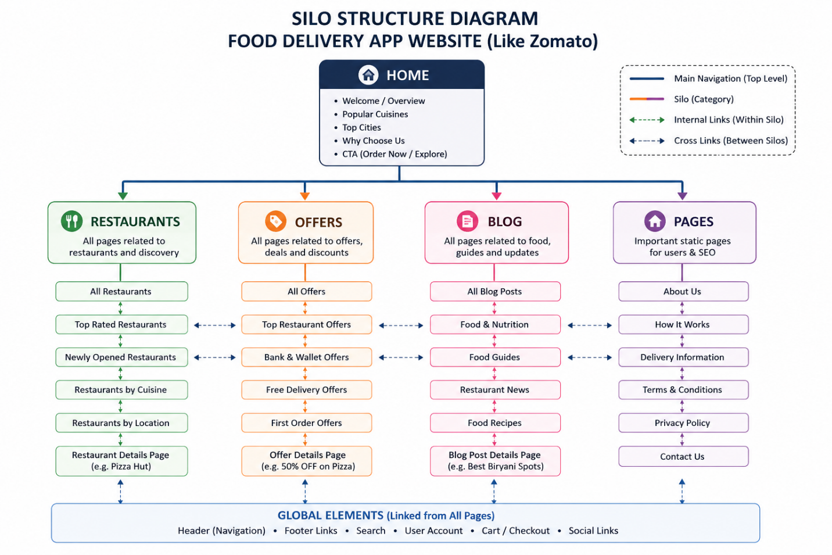
- Rewrite the anchor text for these 4 internal links on a Flipkart-style product page to optimize for relevant keywords: (1) 'See more', (2) 'Click here for reviews', (3) 'Go to similar products', (4) 'Read about returns'.<br><br><em><strong>Hint:</strong> Use terms that match what users might search for, like 'Best smartphone reviews' or 'Easy return policy'.</em>

- “See more” → View more smartphone details and features
- “Click here for reviews” → Read smartphone customer reviews and ratings
- “Go to similar products” → Explore similar smartphones and alternatives
- “Read about returns” → Check our easy returns and refund policy
- Given a list of 6 internal links on a BookMyShow-style movie site, decide which 2 pages should receive the most link juice and explain why. Suggest how you would adjust the internal linking to support this.

For a BookMyShow-style movie website with 6 internal pages, I would give the most link juice to these two pages:
1. Movie Details Page
This page should receive strong internal links because it contains important information about a movie, such as its cast, reviews, trailers, ratings, and showtimes. It can also guide users toward ticket booking.
2. Movie Booking/Tickets Page
This page should receive strong internal links because it is the main conversion page. Users ultimately visit this page to check showtimes and book movie tickets.

How I would adjust internal linking:
- Link the Home Page to popular Movie Details pages.
- Link Bollywood Movies and Hollywood Movies pages to relevant Movie Details pages.
- Link Upcoming Movies to their respective Movie Details pages.
- From every important Movie Details page, add a contextual link to the Booking/Tickets page.
- Use descriptive anchor text such as “Book Tickets,” “Check Showtimes,” and “View Movie Details.”
- Avoid adding too many unnecessary links so that link equity is concentrated on the most important pages.

Final Structure:
Home → Movie Categories → Movie Details → Booking/Tickets

- Pick a topic cluster for a music streaming app (like Spotify), identify one pillar page and at least 3 cluster pages, and describe how you would link them together following the pillar-cluster model.

Topic Cluster: Music Discovery
For a Spotify-like music streaming app, I would create a “Music Discovery” topic cluster.

1. Pillar Page
Complete Guide to Discovering New Music
This page gives a broad overview of music discovery and links to all related cluster pages.

2. Cluster Pages
Cluster Page 1:
Best New Songs to Listen to This Year
Cluster Page 2:
Best Playlists for Different Moods
Cluster Page 3:
How to Discover New Artists and Music
Cluster Page 4:
Best Music Genres to Explore

3. Internal Linking Structure
I would link all cluster pages back to the pillar page and also connect relevant cluster pages with each other.
Structure:
Music Discovery
(Pillar Page)
/ | \
/ | \
New Songs Mood Playlists Discover Artists
\ | /
\ | /
Music Genres

4. How I Would Link Them
- Pillar Page → links to all 4 cluster pages.
- New Songs → links back to the Music Discovery pillar.
- Mood Playlists → links back to the pillar and to relevant genre pages.
- Discover Artists → links back to the pillar and New Songs page.
- Music Genres → links back to the pillar and relevant playlist pages.

Why this structure is useful
The pillar page becomes the main authority page for the topic, while cluster pages provide detailed information about specific subtopics. Internal links help users navigate between related content and help search engines understand that all these pages belong to the same Music Discovery topic.

